**LITERATURE SURVEY**

**PLASMA DONOR APPLICATION**

**Introduction :**

The major contribution of Human Sciences in the understanding of the whole blood donation behavior has been through the study of individuals' motivations and deterrents to donate. However, if whole blood donation has been very widely studied in the last sixty years, we still know very little about plasma donation in voluntary non-remunerated environments. Yet, the need for plasma-derived products has been strongly increasing for some years, and blood collection agencies have to adapt if they want to meet this demand. To overcome the demand of plasma donation we are introducing the plasma donor application which helps the receiptant to receive the plasma and find the donors quickly.

**Abstract :**

This project "PLASMA DONOR APPLICATION" deals with notifying the concerned donor upon request by the Receipient in need of Plasma. This project provides quick access to donors for an immediate requirement of blood. In case of an emergency/surgery, blood procurement is always a major problem which consumes a lot of time. This helps serve the major time-lapse in which a life can be saved.

**Purpose:**

During the COVID 19 crisis, the requirement for plasma became high and the donor count was low. Saving the donor information and helping the need by notifying the current donors would be a helping hand. Regarding the problem faced, an application is to be built which would take the donor details, store them and inform them upon a request.The main objective of this project is to provide the recipient with a donor who is in good form with no health ailments to donate blood of the corresponding blood group.

**Hardware / Software Requirements :**

* RAM:4GB
* CPU:1.6Hz
* Minimum Database Space : 12GB
* Good Internet Connection upto 1MBps.
* Windows 7 or higher.

**Architecture of Application :**

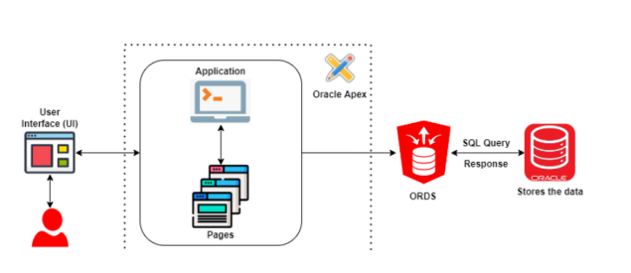

**Flow chart of Application :**

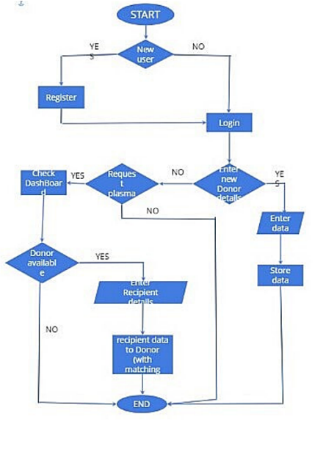

**Overview of System :**

**Register / login :**

The user starting the plasma donor application should login whether the user is donor or receiptant , if the user is new to application the user should Register and then he/she should login to the application.

**Donor Dashboard :**

If the user is a new donor , the user should enter all the details including blood group , contact details ,current location etc.. The data entered by the donor stored by the application .

**Receiptant Dashboard :**

The receiptant should request for the plasma and check the dashboard for the availablity of the plasma donor in their nearest location. if the donor is available the receiptant should enter the details of receiptant , if the details are matched with the donors the details of receiptant entered are send to the particular donors via email , then the donor will accept the request and contact the receiptant. The receiptant can contact the donors directly through contact details provided by the donors.

**Advantages of Proposed Solution:**

* Searching for plasma donors made eassier through plasma donor application.
* Many a times even though the donor is available we can't save the patient as we do not have the information at that time and this application exactly solves that problem by bringing all of the donors and receipients under one umbrella.
* Email Notification is Sent to donors while Receiptant Requesting for plasma and also they can contact the donors by using contact informations provided by donors.
* It is a user-friendly application.
* Any one can access app and know information about the plasma donors .
* Plasma Receiver can check the availability of the plasma donors based on matching blood group.
* Recommendations based on Locations is available so that receiptant can request donors nearby them.
* Notifying the Receiver about the Donor is available.

**Disadvantages of Proposed Solution:**

* Internet is Mandatory to use the Application.
* Reports of donors are not verified.

**Applications:**

* Helps the Receiver's of Plasma in-time.
* In Emergency situations,the donor can be found faster with this application.

**Conclusion :**

The efficient way of finding plasma donor for the infected people is implemented using the plasma donor website that is hosted on Aws platform to ensure smooth functioning of the website operations.I have hosted the website in aws platform to make sure the operations are runing successesfully Aws lambda fuctions is used to deploy the application AWS EC2 service is used.